**Our Motivation**

As we mentaioned in our project proposal, there is a saying regarding Norwegian finance that goes along the lines of “We own all of Champs Elysees”. This outrageous statement is what we set out to explore, and to discover wether or not there is any hold to this. Our goals in the first place were somewhat nebulous, as we were uncertain about what we realistically could do. However we came across this quite substantial data set about the three aspects of investment that the Oil Fund focuses on, Equity, Fixed Income Documents and Real Estate.

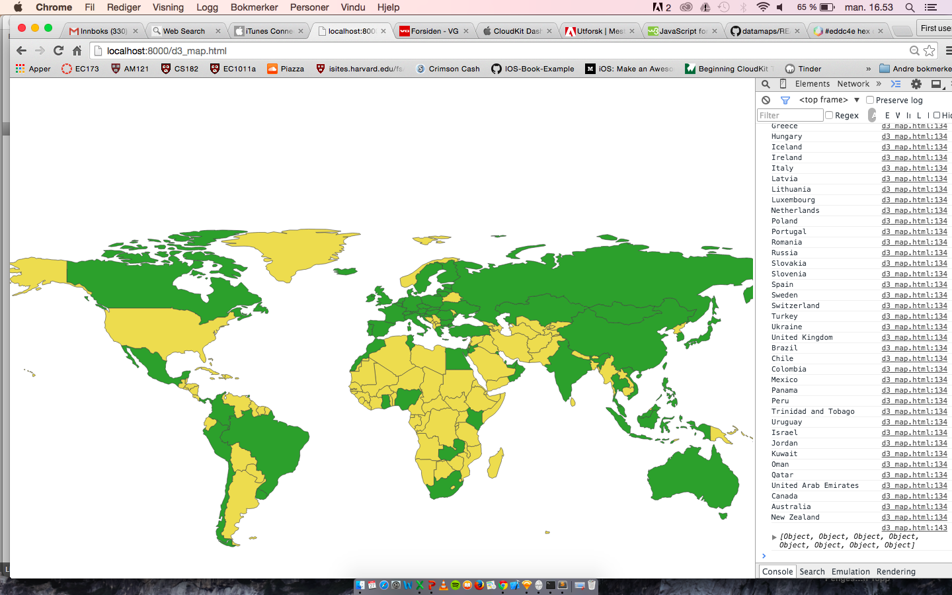

Initially we were mostly interested in the real estate, given our initial motivation for exploring the statement. We spent a great deal of time contemplating how we could cleverly visually represent the vast number of prominent real estate investment the Oil Fund has at its disposal.

The data set provided us with the street names of these investments, and we spent a great deal of time, and eventually we were successful in applying a Google geotag-API that assigned coordinates to the addresses. The biggest problem we had was figuring out why our API only executed a certain number of times, until we realized that the API had a timer limit, and so we had to insert a delay into our function. We then worked on having our JavaScript program write to a new dataset, so this process that took quite a long time with the delay function, would only have to run once. However as we moved along we realized that the real estate is, although the most visible, the least important and smallest part of the total investments of the Oil Fund, amounting to only about 5% of the total invested capital.

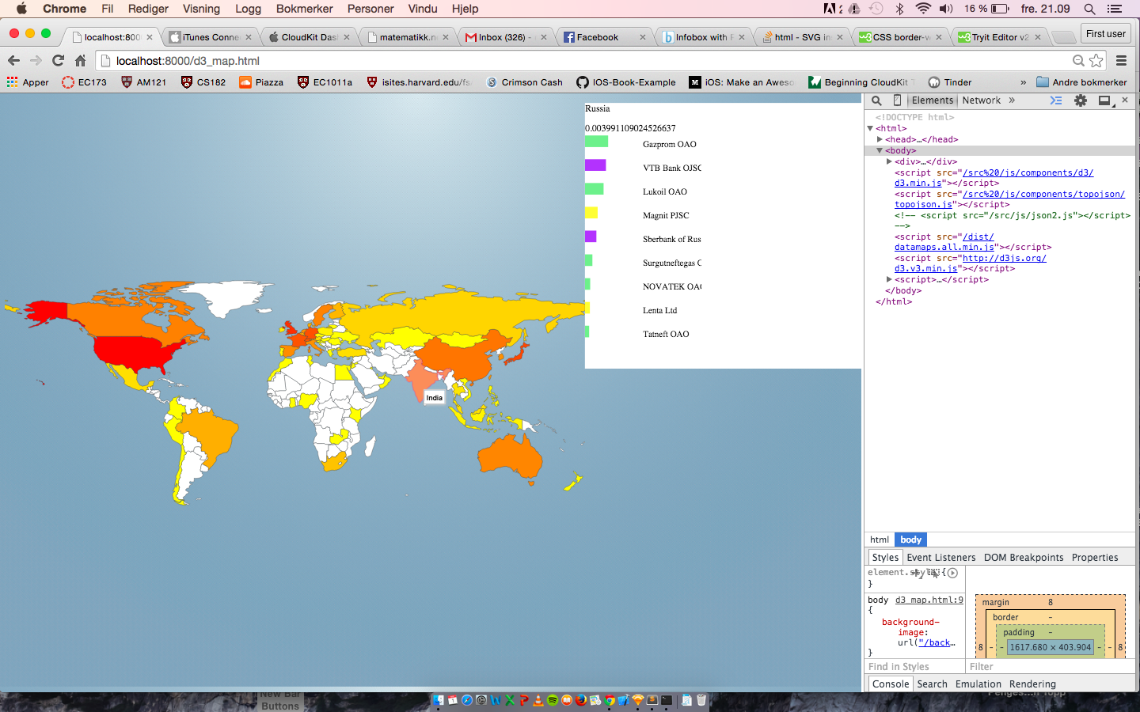

Realizing this we expanded our horizon and moved away from our limited focus on the real estate investment and dove more into the broader range of information that our dataset provided us with. Going along we thought that even though the real estate investment are the most widely recognized asset among most Norwegians, there are other much bigger and more important investments that are mostly omitted from the public’s focus.

We decided then to focus more on the entire trinity of investments that make up the Oil Fund, trying to make comparable visualizations of all three of them. Our end result answers our initial question in the following way: “Yes we do own a big portion of Champs Elysees, Times Square, Brandenburger Tor and other landmark real estate, however, there are other much more lucrative and important areas where our country is more invested in.”

This choice proved to be a very good one, and I think we ended up with a more informative and comprehensive product, where we also got to utilize and explore more sides of the technicalities regarding visual coding. We had to experiment with different local hosts in order to support our PHP-files, and we worked a lot with embedding PHP-code in our HTML alongside JavaScript, which proved not only to give us a better interface, but also taught us a lot in terms of coding. However, due to a crash where we lost some important work we hadn’t git pushed, we were forced to abandon the finished version of the ticker. We managed to salvage most of it, however our PHP code did not update completely so we only get 20 seconds worth of data.

**Our Inspiration**

We got some of our inspiration, and our data from the Norwegian Central Bank’s webpage at [www.nbim.no](http://www.nbim.no)

While this webpage is quite extensive and informative, we found it somewhat hard to navigate and to get comparable visual perspectives. Therefore we sought to extract the essence of the data presented, and compile it into a more compact and graphic exposition. The nbim-website contains a lot of cool features such as the total value ticker. This was one of the inspiring features that made us want to pursue this topic for our final project.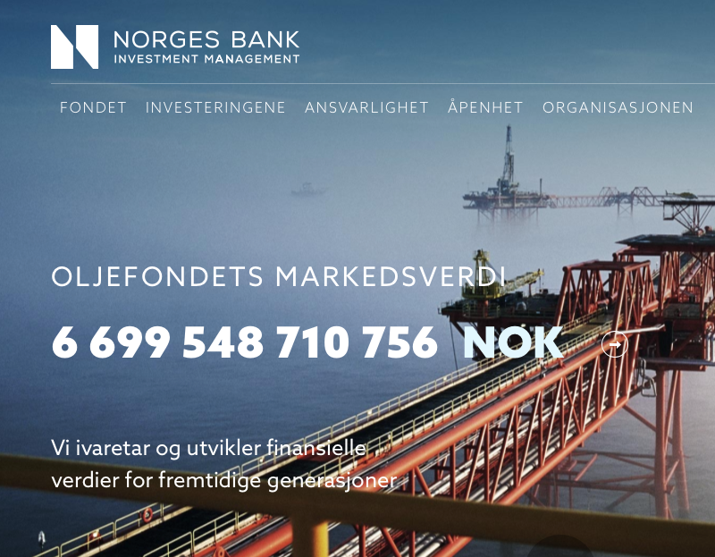

We also consulted a number of CSS webpages for input on how to style our page, for instance our “compare”-button was sourced from [www.cssdeck.com](http://www.cssdeck.com). There are a great deal of online resources for these things, our donut/pie charts for instance, were inspired (and patched together from various places) by different web pages providing snippets of source code.

This is also, as we mentioned, where we downloaded our dataset, which was a large json-file, which initially was very hard to read as there were no whitespace, and the code was all in a single line. To get an overview of the data we had at our disposal, we just console logged the file in our web developer tool in our Chrome browser. This way we got a structured overview of the data, and were able to understand and execute proper indexation. After we abandoned our idea about an exclusive real estate map, we stopped modifying the dataset as we found more than enough data to work with in the existing file.



The whole time we were hooked on the idea of a world map to show the by-country geographical distribution of the Oil Fund’s assets, and we brainstormed many different ideas about how to best represent more in-depth data at the same time. The info-boxes seemed like the best compromise between functionality and visual aesthetics, combined with a straightforward source code. We explored different types of graphs and arrived at our bar charts and interactive pie-diagrams, with different aggregation options and comparability to with other countries. While pie diagrams often can be misguiding and non-informative when dealing with data, we think that the way we ended up employing them as a combined graph and aggregation button was a cool and functional feature. Our bar charts provide a simple linear comparison between different assets in a single or a pair of countries showing the relative magnitude of investment between different investments. The color coding of these bar charts show in what business category the various assets are bound up.

Throughout our process, we initially wanted an accurate geographical pinpoint location map of all the real estate investments, perhaps a color coding of a birds view of the respective streets etc, with info boxes appearing as you hovered over.

**What We Learned**

Besides learning a lot about our nation’s capital investments, we did learn a great deal about how to process and represent data of our choice from scratch. Most challenging perhaps, was our choice to include PHP-elements in for instance our total oil fund ticker on the top of our screen. This required a great deal of work and reading up on how PHP, HTML and JavaScript can work together. We believe we managed to achieve all the goals we set as we re-evaluated our project and shifted course from our real estate perspective, we are able to show comparative information between countries and at the same time show the geographical distribution of assets. There are always things to improve on, both functionality, and perhaps comprehensiveness, that is given more time we would probably have explored ways to show more detailed information, and perhaps more datasets could provide us with a timeline of investments. We would also perhaps have added a converted version of the total fund ticker found on [www.nbim.no](http://www.nbim.no) in dollars rather than Kroner.

All in all we managed to implement more functionality than we had hoped for when we started this project and we gained a great deal of insight in the assets of the Norwegian Oil Fund working this closely with the data and using the final product.

Ole Christian Wendel & Nico Astrup Wiik